What is the Outcome of our actions?
Reduced landfill? Number of bins emptied?
Number of tubs bought by Ian Cole?
Using biodegradable containers means these break down rather than taking decades to decompose.

Why did we do this?
To reduce the amount of landfill waste produced, we pay to have this collected by the council, our aim was to improve recycling around the school. We tried to consider what we do with our waste and also what waste we generate.
50% of all plastic we buy is single use plastic. Plastics make up 8% of the world’s oil use. Single Use plastics end up going to landfill, and they take a long time to breakdown. They can end up getting into rivers and then the world’s Oceans. There are more than 5 trillion pieces of plastic in the Oceans worldwide. By 2050 there could be more plastic than fish in the oceans. This gets consumed by animals and can kill seabirds and fish, micro plastics have been found in human food chains. A lot of plastic is used once and thrown away, this takes a lot of energy and creates a form of waste that is causing damage.

What did we do in the past?
In 2019 the majority of the waste we produce goes to landfill. The main sources of waste are kitchens, classrooms and maintenance of the school site. We have 4 large landfill bins emptied weekly. On the school site there are X bins. We recycle Cardboard (2 large bins), paper (1 large bin), There are 3 plastics bins, 1 glass bin.
Pupils carry out a litter pick every day of the playgrounds to help maintain a clean school site.
We sell food and drink in the canteen to pupils, a large proportion of this was contained in single use plastics.

Completed March 2020 2020
What have we done to reduce this?
In 2019 we began our ‘No plastic days’ to look at the items we buy to reduce plastic waste. From this we have got rid of Styrofoam pasta pots, moved to biodegradable sandwich containers, half of the plastic containers in the canteen are vegware (bioplastics). We no longer give out plastic drinking cups for the water fountain, we have changed to paper cups, or washable cups. No longer have plastic cutlery in the canteen. We give 40p discounts to people using their own containers for takeaways.
The school has carried out an Eco brick project to create bricks out of plastic waste bottles. Competition
The paper we buy for photocopiers is recycled paper. Every classroom has a waste paper bin. The science department have stopped buying glue sticks.
School blazers are made out of recycled plastic bottles. Picnic benches are made of recycled plastic.
Pupils take part in a ‘Big Tidy Up’ litter pick in Beeches Park each year.

Containers made of corn starch and an Eco brick
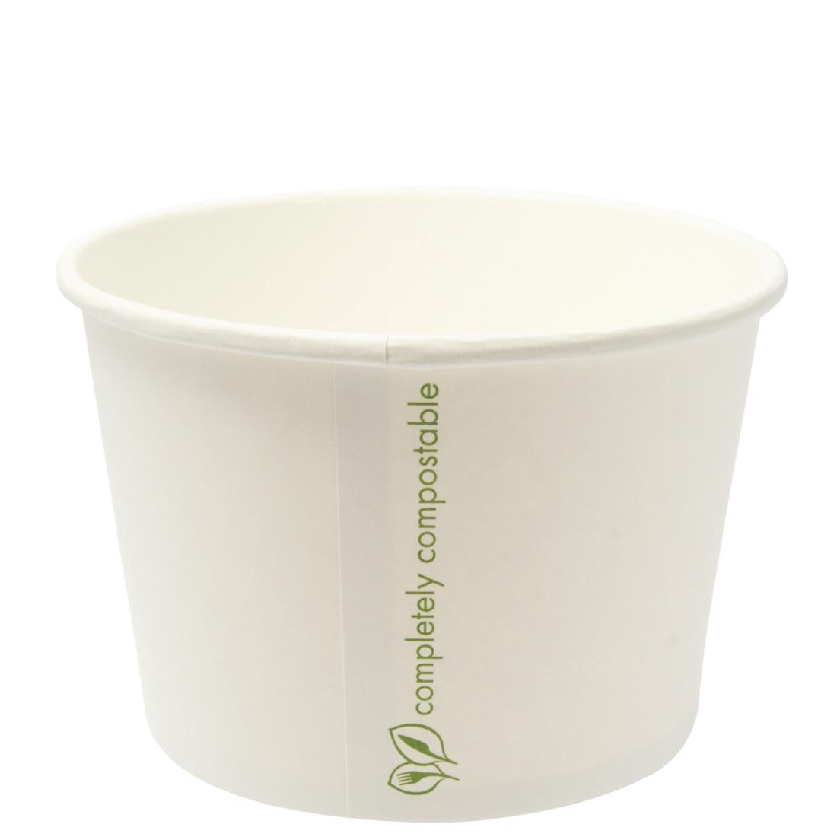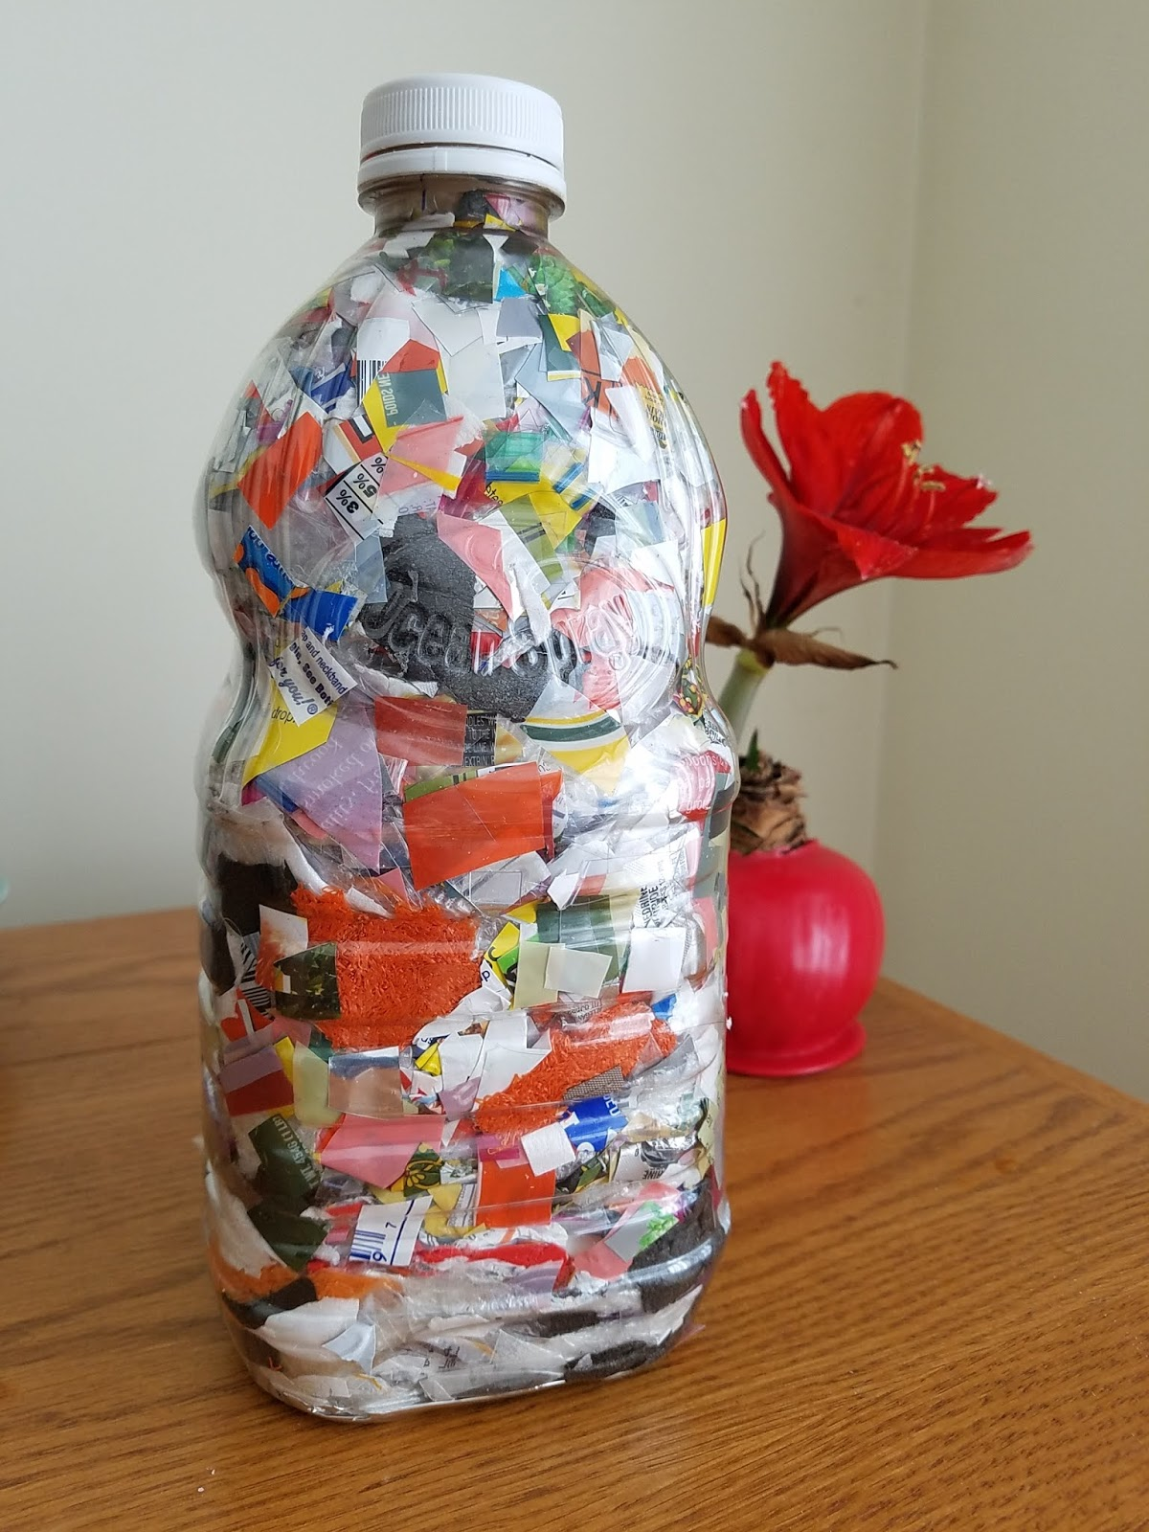

What is next?
In 2020 we are aiming to reduce our plastic waste further, reducing the single use plastic bottles in vending machines. Recycling glue sticks and pens from classrooms.
Composting food waste from the canteens. Recycling campaign for pupils, Pupils bringing in their own drinks bottle. More Plastic bins for recycling. Working with other community groups.

Waste
Balcarras School Information Sheet



