Carbon Dioxide emissions taken from http://www.carbon-calculator.org.uk/
What have we done to reduce this?
1. We have reduced our energy consumption through updating the school facilities, Insulation of all school buildings, the use of passive lighting through solar tubes in tech and science, LED lights are 50% around school, 80% of projectors are, LED floodlights installed 2019, Computers auto switch off, sensor lights in some corridors
2. Modified people’s behaviour, energy surveys, switch off days, thick jumper days, climate conferences
3. Planted trees around the school grounds, off-setting CO2 output
4. Purchased two 10KW photo voltaic Solar panels

Tree planting and Solar panels

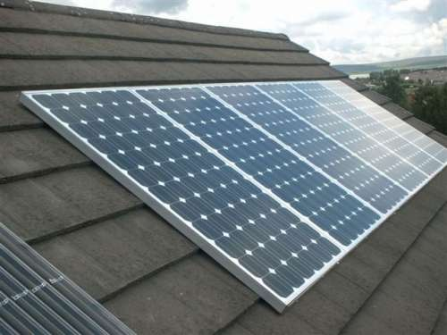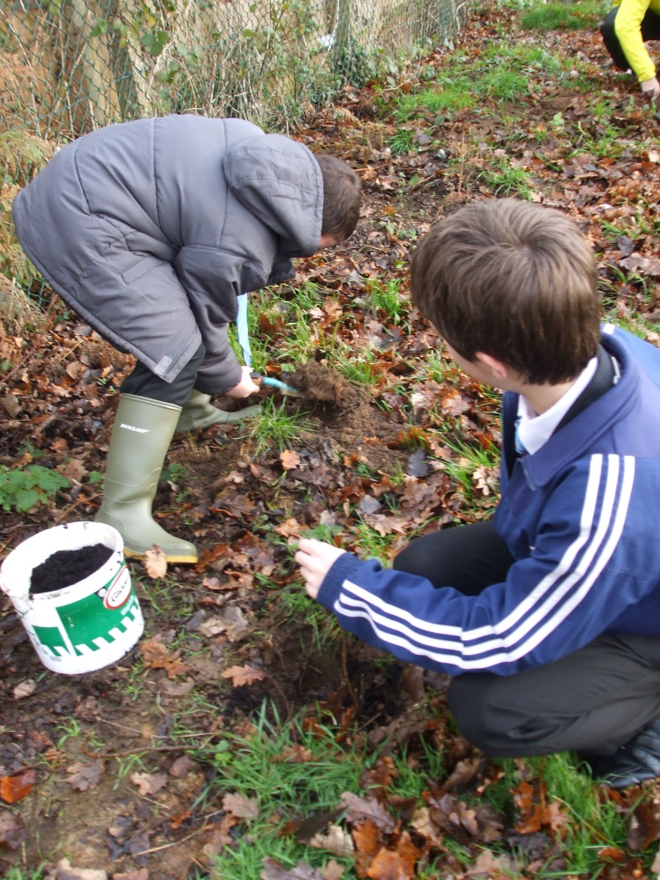

Completed Jan 2020
What is the Outcome of our actions?
We have reduced our CO2 output by a combination of energy reduction, offsetting and behaviour modification.
The Solar panels that were purchased provide free electricity and we receive a Feed In tariff from the government for energy generation. In 2017 we made 18,084kwhr of free renewable energy.
kw

What is next?
We aim to continue to reduce the energy consumed per person at the school, through education, upgrading facilities and energy generation.
We are part of a multi Academy Trust, and the new school we are twinned with is aiming to be a Carbon Neutral school.

What did we do in the past?
In 2015 we produced 440 tonnes of CO2 for heating and lighting the school. 214 tonnes came from burning gas to heat the school, 226 tonnes came from using electricity for computers (850) and lighting.

Why did we do this?
Using energy puts out Carbon Dioxide into the atmosphere, this contributes to a warming climate. Over the last 100 years the global temperature rose by 0.6C, this can cause a range of effects.
We have tried to reduce our wastage when it comes to using energy. By generating our own energy from solar panels we avoid using electricity generated from burning of fossil fuels (around half of all UK electricity is made in this way).
By reducing the energy we consume as a school we reduce our carbon footprint and also save money.

Energy
Balcarras School Information Sheet



