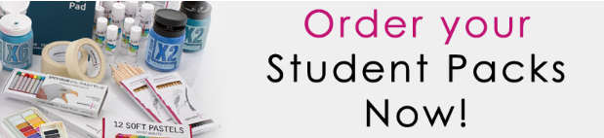

Balcarras Art department are once again offering students who are studying Art at GCSE the opportunity to purchase an “Art Pack”. The pack will contain the basic, but necessary equipment with which to support student’s coursework, both in and out of school.
COVID: Given the current situation we feel it very important that pupils have access to their own equipment as far as possible, enabling us to cut down on the amount of shared equipment that pupils will come into contact with.
Pupils not purchasing an art pack will need to provide an A3 flip folder in which to store and present their work.
ITEM
A3 “Flip” Folder for presenting work
A4 Sketch Pad
Starter Set Acrylics
Oil Pastel Set
Watercolour Box Set
Coloured Pencils x12
Brush Set x4
Black Fineliners x3
Gluestick
Drawing Pencils x4
Blending Stumps Set of 8
Putty Rubber
Pencil Sharpener
White Gel Pen
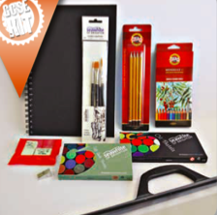

For illustration only

Payment should be made online through the school’s website
DEADLINE FOR PAYMENT: MONDAY 14th SEPTEMBER

--------------------------------------------------------------------
I would like to place an order for a GCSE art pack and enclose cheque to the value of £27 (Please make cheques payable to Balcarras School)
Students Name____________________________________________
Tutor Group_______________________________________________

