Covid Rules

Please read the rules below carefully. All pupils must follow the rules exactly.
- Pupils must stay in Year Group Bubbles – please do not mix, at any time, with pupils in other year groups. This includes break time, lunch time, study periods and when travelling to and from school.  - Pupils should go straight to their classroom at the start of each lesson by the most direct route.  - Pupils must follow the One-Way-System. |  | 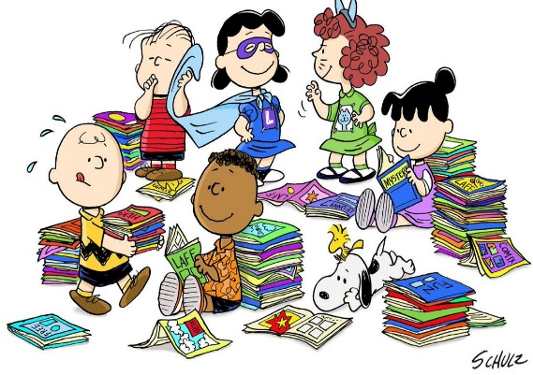
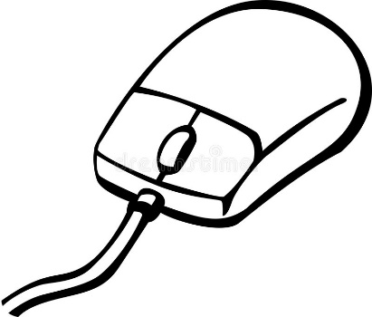 | - Pupils should wipe down their table, keyboard, mouse etc. at the start of each lesson.  - Teachers will need to keep socially distanced from the pupils, and so cannot offer the usual close support.
- Pupils should try to minimise congestion around the school’s entrances and exits. Wait patiently for doorways to clear when busy.  - Good hygiene is essential, wash hands regularly, carry hand sanitiser with you, use a tissue for sneezes and coughs. |  |  | 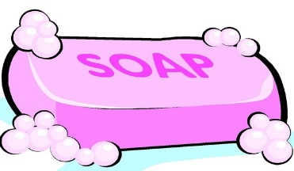
 | - Pupils must use the entrance and exit to each classroom as specified by the teacher. Sometimes the fire exit will be the safest route.  - Pupils should not share equipment.  - Pupils cannot leave their classroom or wander around the corridors to find a teacher. Use e-mail communication if you need to ask a question of a teacher.

- Equipment: All pupils should bring with them every day:  - hand sanitiser  - small packet of disinfectant wipes  - glue stick  - safe scissors  - colouring pencils/pens |  |  |  | 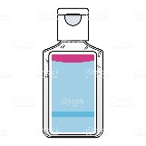  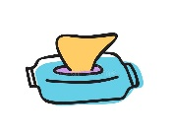
  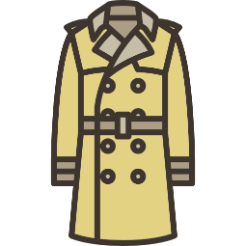 |  | - Pupils cannot access their tutor room at break and lunch, as other lessons are taking place. If a pupil has a locker in a corridor, then bags can be stored in lockers. If not, pupils will need to carry their bags with them. (Do not leave expensive equipment on the coat hooks outside the canteen.)  - Pupils cannot access their tutor room during Wet Breaks, as other lessons are taking place. Pupils should bring an umbrella and coat to school whenever rain is forecast.
- Extra Curricular clubs will be minimal for the present. Pupils must follow the rotas for using the library, homework clubs and other activities.  - No pupils (including prefects & sixth form) are allowed off site at any time, unless they have a letter from parents and have signed out at reception.  - Pupils need to be aware that lessons will be taking place for other pupils at break and lunch times. Pupils must respect quiet areas near to classrooms. |  |  | 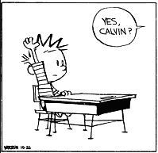
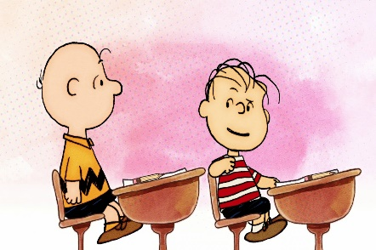 | - Pupils must go straight home at the end of the day. Do not wait for friends at the front gate or the back gate. Do not loiter at the shops.  - Head of House. Heads of House (and Heads of Year in Sixth Form) are happy to see pupils to offer support and guidance. However, to avoid congestion in the main corridor, pupils should use the e-mail system to contact their HoH/HoY first, so a meeting can be arranged.

