Dear Parent/ Guardian,
Bronze Duke of Edinburgh Award – Enrolment

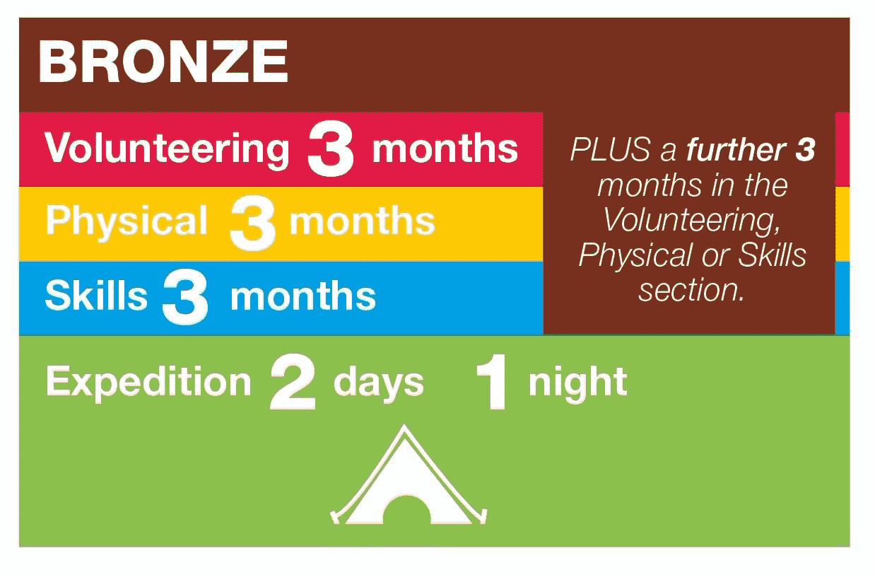
Your son/daughter has expressed an interest in the Bronze Duke of Edinburgh Award. This is a national scheme where students engage with a number of activities over the course of the year that if completed, will earn them the Bronze Award. To achieve this, students must complete 3 ‘sections’ of varying length and an expedition next summer. Details of this are outlined in the infographic below.
Your son/daughter will have attended a meeting that explains what is involved in these sections, but I would also encourage you to peruse the DofE website for more information https://www.dofe.org/do/ideas/
Students will also have been given a DofE booklet. This is an important document in the application process and is the place they will make notes throughout their training this year.

To be accepted onto the scheme, all of the following must be completed by Monday 28th September at 3:10pm. Payments made without application will be automatically refunded. Applications submitted after this date will not be considered under any circumstances.
- Have a good school behavioural record.
- Submit the DofE booklet with completed details of what will be done for each section and who will be the assessor.
- A short letter (about half a side of A4) detailing why you want to complete the award.
- Make payment of £35 via scopay. This is to cover the enrolment fee. Additional expedition fees will be requested at a later date, but I expect it to be less than £100. The final price is dependent on the size of the cohort. Parental consent for enrolment to the award is assumed upon receipt of payment.
- Be available for the practice walk on Saturday 17th April and the final expedition on the weekend of 24th + 25th April.
For more information, there are FAQs attached to this letter. Should you have any other questions do get in contact with me via email.

Your sincerely,
James Butler
Bronze DofE Co-ordinator

FAQs
Sections
Q. What is eDofE?
A. This is the online DofE portal. Your child will be issued a login after the initial recruitment stage. It is vital that students complete their ‘programme planners’ (where they state what they will do for each section) asap after enrolment and upload evidence to their eDofE portal as they go. This is how we approve their sections and ultimately their award. There is also an eDofE app.

Q. What can my child do for each of the sections?
A. More information can be found on the DofE website https://www.dofe.org/do/ideas/. If your child is involved with an extra-curricular sports club, this would be a good starting place for the physical section. For the skill section, a good example would be learning a musical instrument or cooking. For the volunteering section, there are various online and in person opportunities. However, you cannot volunteer somewhere that makes profit from your work. Each section must have a specific focus. For example, learning how to cook a curry using a variety of spices or be able to run 5k using the couch – 5k app.

Q. Who can be my child’s assessor?
A. Mr Butler can be the assessor for one section. Your child does not have to ask permission for this. Another section can be any other teacher at school. We encourage students to seek out their tutor as a starting point. Students must ask a teacher kindly for permission first, before electing them as an assessor. The third section must be someone outside of school. A sports coach or instrumental teacher for example. An assessor can not be a family member though!

Q. How does my child complete a section?
A. They must submit a ‘programme planner’ on eDofE. This is a digital copy of their plan for that section. Upon approval by school, they can then upload evidence on eDofE and have their assessor complete an assessor’s report card upon completion.

Q. How does my child log an assessor report for each section?
A. An assessor’s report card can be done by the assessors online here https://www.dofe.org/assessor/. This is the preferred method as it requires the assessors to complete the report online. It then comes direct to our inbox for approval. Your child must use the slips at the back of the DofE booklet to communicate with their assessors (particular for school staff) and to help the assessors complete the report. Alternatively, assessors can write the report card by hand (again attached towards the back of the booklet). All sections of the card must be completed and then an image uploaded to eDofE. The most important thing with the assessor’s report is that the assessor is the same person as was stated in the programme planner, and that the allotted timeframe is met. Even if the timeframe is 1 day short, it will be rejected.

Q. Why does my child have to complete the sections by Easter?
A. This is because after the expedition in year 10, the demands of the upcoming Y11 GCSE year as well as end of term fatigue mean students often do not complete the award if their sections are not completed before expedition. We really want the students to be awarded the Bronze status, so that is why we set this timeframe.

Expedition
Q. When is training for the expedition?
A. After the initial recruitment process, there will be intensive training 3 times per week after school in the first 2 weeks after Christmas, followed by regular Tuesday after school meetings thereafter. Please make arrangements for your child to get home afterwards safely.

Q. How much will the expedition cost?
A. This will vary depending on kit requirements, the cost of campsites and other organisational expenses. We will be in touch closer to the time with an expedition letter.

Q. Where will the expeditions be?
A. The practice expedition starts near Brockhampton and finishes at school. The final expedition will start at Fish Hill Car Park (near Broadway Tower), camping at Hayles Fruit Farm & finishing on Cleeve Hill. Exact locations TBC.

Q. Who will be in my child’s expedition team?
A. Your child will group up with their friends closer to the time. Teams must be in groups of 4 – 7. These teams are not final however and we may have to split groups if needed.

Q. What about kit/ equipment for the expedition?
A. A full kit list is included in the booklet. Rucksacks, stoves (trangias) and tents can be loaned to your child by the school nearer the time. If this kit is broken or lost however, we will need to charge for it. We do encourage the students to use their own tents/ rucksacks if they have them. DofE regulations state that students cannot sleep alone so 1-man tents are not appropriate. When buying kit you do get discounts at various outdoor stores. See the link for more info https://www.dofe.org/shop/participants-parents-dofe-card/

Q. What about food for the expedition?
A. Students will plan their meals and will need to do a team shop beforehand to buy the food needed.

Q. As a parent, do I need to be around for the expedition?
A. A parent or someone in your child’s expedition group will need to drop your child at the start and pick up at the end locations. Car sharing is encouraged. In case your child needs to be removed from the expedition due to an emergency, we do ask that someone is available 24hrs a day if needed.

Q. What if the kit requirement is too expensive for me?
A. Please contact Mr Butler for more information.

Other
Q. How do I contact you for more info?
A. Contact Mr Butler on jxb@balcarras.gloucs.sch.uk. Please only make contact if necessary.

Q. As a parent, do I have to do anything throughout the year?
A. Encourage your child and check they are completing their eDofE as required. One of the biggest barriers to students attaining their award is not completing the necessary information on eDofE. Your support in helping them keep on top of this is really appreciated.

Q. What are the benefits of doing the DofE?
A. Teamwork, leadership, sense of responsibility, independence, forming new relationships, problem solving are skills students commonly say they have improved when doing DofE.

Q. Balancing the time requirements of the DofE with other extra-curricular commitments?
A. Completing the award is a significant time commitment. Some efficiencies can be made where a ‘section’ aligns with ongoing extra-curricular commitments such as a sports club or instrumental lessons, but the time required for completion should be carefully considered before applying.

Q. What does my child get upon completion?
A. Students will receive a certificate in the post from the DofE. They will also receive a DofE badge to wear on the lapel of their blazer. It also gives students access to Gold DofE in year 12.

