Minutes The Green Group Meeting
Monday 29th June 2026 in the Pastoral Meeting Room at 3.45pm
Present; Ian Davidson, Dominic Burke, Andy Cadogan, Jon Pearce
Apologies; Pupils from Eco club, Mrs Gregory, Cheryl Crowley, Mark Constance, Raechael Kelly Macloed, Isla Kelly-Macloed
1. Matters arising from last meeting, JWP had a meeting with Paula from Lets Go zero, a charity looking at how schools can meet zero carbon emissions targets. One suggestion was to get a live smart energy meter. Having spoken with Louise Morgan in finance we have electricity meters, but the smart meters cost more money. JWP to collect data on electricity used and waste produced.
IGD gave the latest figures for the optimiser that was installed. It has saved £13,000 in 18 months and has saved 36,853kw/hrs of energy. IGD to get a login for JWP. So these figures can be published.
2. Heat/Flood Adaptations to changing climate, last meeting we discussed flood prone areas, and putting on window film to the English block. We had a heat wave last week and we made some other adaptions; pupils wore PE kits, Early finish days to avoid the heat of the day, messages to parents. New fans purchased. Closed warmest rooms in top floor of English, art and upstairs in languages, and re-roomed in A/C rooms. The school has 29 A/C rooms of which 17 are classrooms. JWP to map out flood and heat adaptions with Year 8 classes in geography.
3. 6th form car park improvements, We have received £5,000 grant from council as part of a modeshift stars application, put tpgether by Gary Towers. This has been for improvements to make travel to school safer for pupils, and to encourage walking and cycling. A group of 6th formers and the Ecoclub with JWP have put forward a proposal to put in a pedestrian pathway in the staff car park, to clearly mark where is safe to walk. The Ecoclub went out and carried out a survey to see how busy the car park gets at the end of the school day. Andy has asked for three quotes on how much it would cost to put in a walkway.
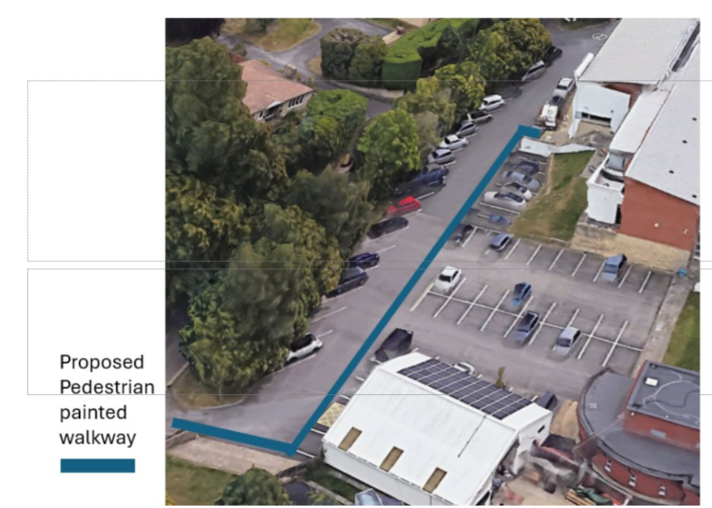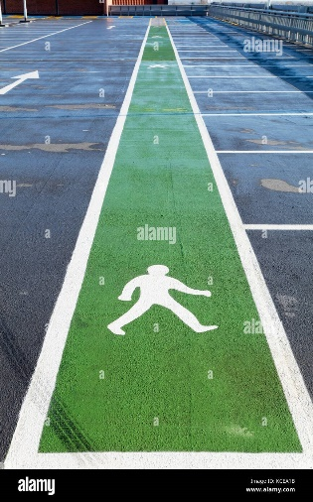
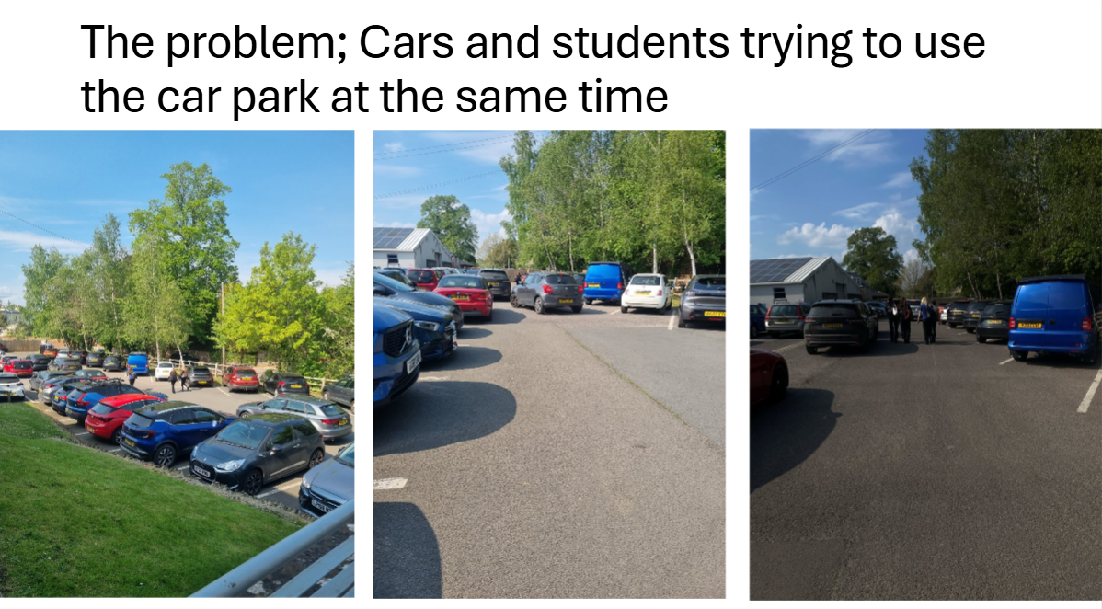
4. The Gen Juice refillable drinks station in the canteen is a success. A lot of the bottles were sold in the first week. This has reduced the amount of single use bottles we sell. People can also use it to refill their water bottles. Jamie Weller has added water bottles to his epraise rewards section, and is looking for a way to offer juice tokens to the epraise awards.
5. The eco club and Site team have been working on the Science pond, they have cleared all of the vegetation from the pond and removed the old liner. Andy has got hold of a new fibreglass liner which he will put in with Harley as a new pond over the summer.
JWP and the Ecoclub also planted 60 new native hedgerow plants along the right hand side of the field. These were from the Woodland trust. JWP have been out to maintain these trees. Andrew the groundsman to help strim back the grass from these saplings.
AOB IGD mentioned that Commercial who provided the optimiser have some AI smart plugs that can help with reduction of energy load, IGD to get some test plugs to trial their use, also to see if we can get a free survey of where would be a good place to test them out.

Dates for next academic year:
19/10/2026
18/01/2026
14/06/2026
The Davidson Building is booked for next year.

