Each week there is an Eco Club that meet up, this is in 7A6 with Mr Pearce, we look at how to reduce the impact of the school.

Every term we have a Green Group meeting which is made up of people from across the school community. This includes the Headmaster, SLT, teachers, support staff, parents and pupils.

Here is an example of the minutes from one of our last meetings.

Our aim is to reduce the Environmental Impact of the school.



MINUTES

The Green Group Meeting

Monday 20th Jan 2025
in 11A1 at 3.45pm

Present; Ian Davidson, Jon Pearce, Andy Cadogan, Quinn Farlow, Cheryl Crowley, Isla Kelly Macleod, Nico Donaldson, Naomi Kelly, Delilah Hamada, Thalia Osbourne Jones, Tiffany Zikayo.
Apologies; Dominic Burke, Mark Constance, Raechel Kelly Macleod.

1. Matters arising from last meeting; There are now 6 battery bins around the school thanks to Andy. One in the staff room, reception, Site compound and Tech. Andy asked where to put the others; the library and 6th form were suggested.
Ian Gave an update on the Electric Car Chargers in the car park. These are open to anyone to use, some staff and visitors have started using these. You pay with an app and this covers the cost of the electricity.
The optimiser has been installed in the compound, in Start of Dec 2024. This saved the school £1,276 in the first two months from our electricity bill. This should give us a pay back period of less than 2 years. After which we will be saving money (and electricity).

2. Thick jumper day, was a success, we turned the heating down. The Eco club picked out two winners of the best thick jumpers on the day. Lots of awareness of saving energy around the school. Isla pointed out that this has also been taken up by the High School Leckhampton as an annual event.

3. The Climate Change debate in the Council Chambers in Cheltenham on 19th Nov was a success, 7 pupils from the Ecoclub attended. The pupils defended the position of USA on climate change. Despite getting lots of tricky questions from other schools they managed to articulate their opinions and were one of the best schools in terms of engagement and communication. Amy even managed to get onto the local news. JWP added an article in the school newsletter and the website.

4. The Eco club have built two permanent Pollution Monitors for the school with the help of Hannah Leatherland, the Cheltenham Green Air Education officer. We discussed locations for these where they would have electricity and Wifi. The Eco group have also been around the school looking at Wifi connectivity.
(Update as of 24/6/25; One was put in from the Maths office near the staff car park, the other has been installed by Geography and the beeches gate)
These are now Live https://map.cheltenham.space/ They show the levels of Particulate matter go up during rush hour, (PM 2.5 up to 3.4ug) but overall levels are below the WHO recommended levels (PM 2.5 5ug) . Which shows we have clean air around our school.
5. The Inter tutor Eco-challenge was launched to the whole school. Over a fortnight each tutor group was encouraged to carry out some actions to make the school a greener place. These included Recycling pens clothes, batteries. Saving energy from turning off lights and computers. Travel to school. Plus spending some time outdoors.
This sheet was sent out to all year groups in the school via tutors.

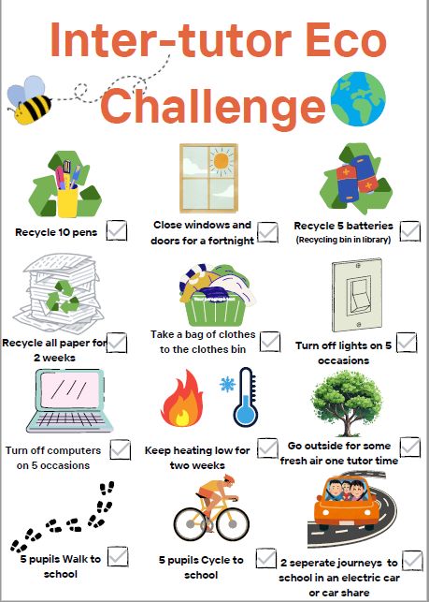

There were lots of tutor groups that took part in this, and there were over 200 separate actions that pupils took over the fortnight to reduce their environmental impact. The winners were 701 showed the most consistent set of actions; they recycled 3 bags of clothes, and had multiple numbers of pupils who took actions. They won a free breakfast roll from the canteen.

6. AOB The librarian had been talking about organising a book swap event similar to the Clothes swap event. JWP has been in contact with the PTFA who organise the sale of second hand school uniform each term. This reuses a resource that is not accepted at Charity shops. There is scope to look at incorporating reuse of other items at these events (books, equipment, normal clothes)

Andy mentioned that in Spring his team will be doing some tree planting of hedges at the top of the school field and invited the Eco club to get involved with this. Free trees have been ordered from the Woodland trust.

Andy also discussed some ideas for the Science pond; replacing the path, clearing the pond out and relining this, adding in some habitats for wildlife. Eco group to come up with some ideas for this area.

Andy also discussed the compost area behind the Astro. There is a new area to the left of the Astro with pallets to create separate compost bays.

Date of next meeting: 30/6/25

