

Levels 2 & 3 Bikeability Cycle Training

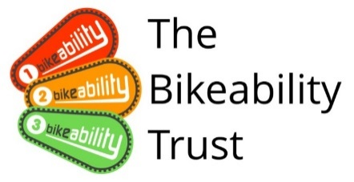

WHAT IS BIKEABILITY? Bikeability is the national cycle training programme supported and funded by the Department for Transport. The course builds the skills and confidence of children who can already ride. Bikeability doesn’t only make children better cyclists - potentially for the rest of their lives - but can help with general confidence and independent thinking. All of our Bikeability training is delivered by qualified, professional, DBS checked National Standard Instructors. Visit www.bikeability.org.uk for more information.
This practical and enjoyable training will-
- Help your child develop their skills and understanding as a safe road user.
- Help them to be physically active and safe as part of a healthy lifestyle.
- Help their personal development building self confidence and independence.
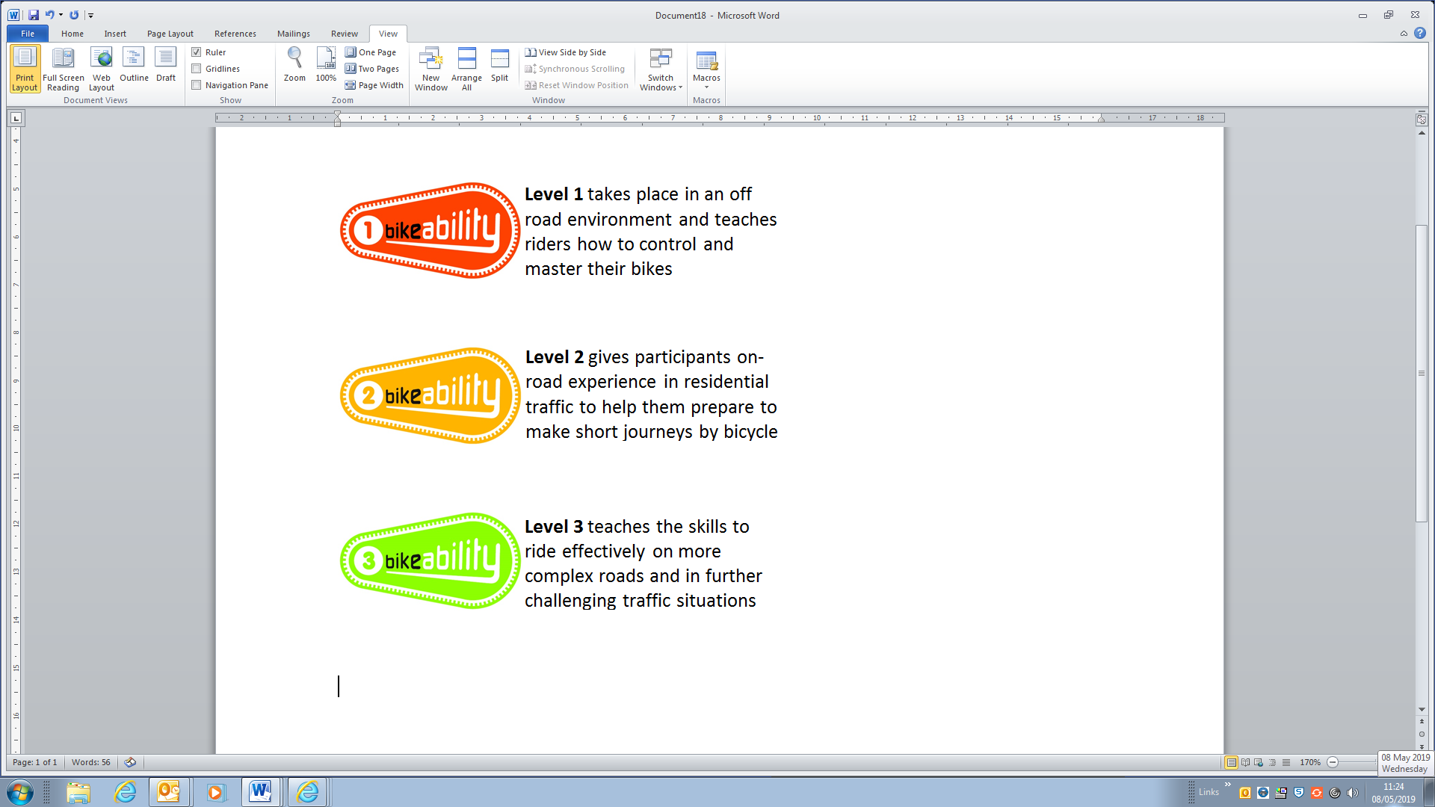
If you would like your child to take part please read through the following information.
This course develops the cycling skills and confidence of children who can already cycle. To benefit from Bikeability, your child must attend every session and practice what they learn after training. Bikeability skills and confidence will be lost without regular cycling. Bikeability engenders enthusiasm while building skills and confidence to cycle more safely, more often. Please support and encourage your child to continue cycling after training.
HOW TO BOOK Bikeability places are booked on the schools Scopay account. Accessed via the schools website.
Training is delivered on behalf of the school by Gloucestershire County Council, Shire Hall, Gloucester, GL1 2TH. Tel. (01452) 425926 e-mail roadsafety@gloucestershire.gov.uk

PRE-COURSE BIKE SAFETY CHECK – Before bringing your child’s bike to school for the course please check the following …

Remember your…
A
Ensure both your front and back brakes work properly
Clean and oil your chain regularly to ensure that it is running smoothly
Run through all your gears
Check both your front and back tyres are pumped up
Make sure your handlebars, wheels and saddle are fixed on tight
Air
B
Brakes
C
Chain
before every ride

COURSE INFORMATION | WHAT WILL YOUR CHILD NEED?
- Bikeability Levels 2 and 3  - Dates – week commencing 20/10/25 and 8/12/25 – you will be told which date.  - Cost – £9 (unless eligible for free school meals) | • A complete consent form (see below)  • A roadworthy bike without stabilisers (see ABC checklist above)  • A helmet  • Suitable clothing for the weather conditions

HOW TO BOOK Bikeability places are booked on the schools Scopay account. Accessed via the schools website. Please complete this by Fri 3rd October 2025 to allow time to create groups.
By completing Scopay you will provide Medical information, and you give consent to your child (or the above child for whom I take responsibility) to take cycling lessons and related activities, which may include cycle maintenance as well as riding on the public highway. I understand that this information is retained by my child’s school and used to ensure my child is eligible to undertake Bikeability training.

By completing Scopay you agree with these conditions
- I agree to my son/daughter taking part in cycle training.
- My son/daughter can already ride a bike (you child will be unable to do L3 Bikeability if they cannot ride a bike).
- The instructors may refuse to train my child if they deem his/her cycle to be un-roadworthy.
- It remains my responsibility to ensure my child does not ride an un-roadworthy bike and if I am in doubt as to whether a cycle is roadworthy I should seek the advice of a professional mechanic.
- Instructors may at any time refuse to continue to train my child if his/her behaviour or cycling ability is deemed unsuitable.
- Gloucestershire County Council will not be responsible for any injury or liable for any loss or damage to participant’s cycles and other belongings.
- It is recommended that trainees wear a helmet and it may be a requirement of the school.
- I agree to encourage my child to practice between each session and after the completion of training.
- I consent to the Bikeability instructor ‘adjusting’ my child’s helmet if required, however I confirm they are not responsible for the physical condition or appropriate fitting of the helmet.
- I consent to qualified instructors administering first aid to my child if required.
- I understand that pupil data collected will be used to support the delivery and monitoring of training sessions/courses.
- I understand that aggregated and anonymised data will be shared with the Department of Transport for monitoring purposes.

Privacy Information
Any information you provide will be treated as confidential and in accordance with UK data protection legislation. We will keep and use your information for booking, organising and conducting road safety cycle training as part of the Bikeability Scheme. With your full consent, we may also photograph and/or film your child taking part in the scheme to help promote Bikeability. The information provided may also be shared with the Department for Transport, and be used for the wider purpose of providing statistical data used to assist with monitoring provision and applying for funding where relevant. Any information provided will not be shared with or passed on to any other third party. From September 2021 The Department of Transport have asked that Schools collect and report on the ethnicity of children attending For full information on how we use your and your child’s information, and how to exercise your rights under the Data Protection Act, please visithttps://www.gloucestershire.gov.uk/council-and-democracy/data-protection/service-specific-privacy-.

Love to Ride

Gloucestershire County Council is currently promoting Love to Ride as tool for increasing adult participation in cycling. Click on www.lovetoride.net to register, log rides, chances to win prizes and be part of the Gloucestershire cycling community through work place or individual engagement.



