
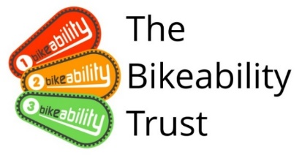
February Half Term Bikeability Courses
Bikeability courses give children and young people the skills and confidence to make journeys by bike.
Tuesday 18th to Friday 21st February 2025
Skillzone, Tuffley Lane, Gloucester, GL4 0AS
Courses delivered by friendly, experienced and fully qualified Cycling Instructors
Small group sizes
£8 for a 4-hour course
Ages 9 to 14 (Level 1, 2 & 3 Bikeability available)

For a booking form and further information please email thinktravel@gloucestershire.gov.uk


